Glory Mgboji

CHEM483

February 23, 2016

“Effect of pH on Flocculation of SDS Micelles by Al3+” Analysis

**Title**

The title of this article, “Effect of pH on Flocculation of SDS Micelles by Al3+,” serves its intended purpose, which is to concisely portray the main concepts of the lab to the reader. From the title, one can conclude that the flocculation, or cluster formation of Sodium dodecyl sulfate micelles, will be affected in one way or another by a change in hydrogen ion concentration. However, the title does not explicitly explain the purpose of the aluminum ion in the experiment. It is unclear state whether the ion will directly participate as an independent variable or merely as a constant in the set up conditions. Thus, the simple substitution of “by Al3+” with “in the presence of Al3+” would make the reader’s inferences about the experimental setup and observations much clearer.

**Abstract**

The abstract of this article is very brief, and lacks in some important areas. This section gives the reader a succinct summary of the main objectives of the lab, including the reigning idea that SDS micelle flocculation is influenced not only by SDS concentration itself, but by the concentration of Al3+ ion, and hydrogen ion concentration as well. The main objectives behind this experiment are present, including the facts that pH changes strongly impact the aluminum ion solution chemistry, and that protons at low pH will compete with the aluminum for micelles. However, the paper seems to jump to the claim that increases in pH result in increases in flocculation at high levels of Al3+without first describing a working hypothesis. Thus, it is difficult for the reader to separate the underlying theory from the actual predictions made prior to performing the experiment.

While it does provide a short description of the main objectives, results, and conclusion, it fails to give the reader a general idea of the methods and procedures used in the experiment. Without receiving a brief summary of the methods, readers searching for specific procedures are unable to determine whether the paper will be useful from the beginning of the reading.

The abstract ends with a brief conclusion that gives the reader some useful insight pertaining to the potential applications for the results of the experiment. The lacking hypothesis, discussion of predictions, and procedures, however, weaken the abstract as a whole.

**Introduction**

The introduction lists a few specific scientific concepts relating to the experiment. These concepts include the neutralization of electrostatic repulsion with the addition of positively charged ions like Al3+, the separation of pollutants from aqueous solution via Adsorptive Micellar Flocculation, and factors that affect the applicability of AMF, such as heavy metals and pH. The provided information helps the reader gain a better understanding of the background behind the experiment; however, the authors of the paper assume that the audience has substantial background knowledge on surfactants. The paper fails to briefly mention SDS’s amphiphilic nature and the commonly accepted mechanism for micelle formation. The addition of these pieces of information would make the introduction more cohesive for readers.

Below are the first two figures referenced in the introduction. The authors included Figure 1 to show the changes in the ratio of current SDS concentration in solution versus initial SDS concentration with increasing aluminum ion concentration. In the text they note that the graph shows an increase in solubility of SDS at higher Al3+ concentrations. This simple realization is not easily conveyed in the graph. The graph is difficult for someone without prior knowledge of the main objectives to interpret at a glance. The addition of a title that clearly clarifies the observed relationship like, “Aluminum ion concentration vs SDS solubility” would aid in making the figures and their descriptions easier to understand and analyze.

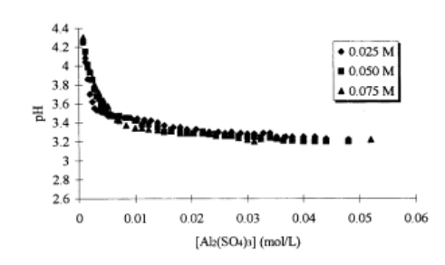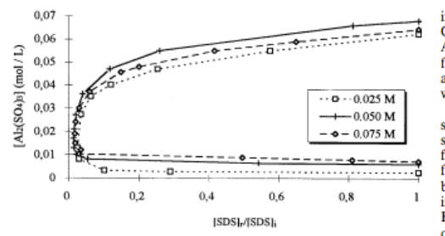

Figure 2

Figure 1

Figure 2 also should have a title to easily point out the relationships being shown in the graph. Its purpose is to display a decrease in pH with increasing Al3+ concentration until reaching a pH of 3.2-3.4. A point of concern for this graph is the choice of data display. All of the data points seem to merge together, making it very difficult to see how the pH vs. Al3+ relationship changes with varying concentrations. Also, the legend’s purpose is rather confusing. Though the x-axis already measures concentration of Al3+, the legend displays different symbols for concentration as well and has no further explanation in the caption as to what concentrations it refers to. This makes it extremely difficult for individuals to interpret, as some information seems to be missing.

Another point of concern is the brief description of AOS, or alpha-olefinsulfonate, at the very beginning of the introduction. The introduction would be stronger without this addition, as the information seems out of place. In fact, it only has one appearance in the entire article and does not strongly support the following ideas.

As mentioned above, the article fails to clearly state and support a hypothesis. It references a few articles in order describe relevant findings about Al3+ behavior under various pH conditions, but it does not show the link between these findings and the experimental predictions made as a result of them. Rather, the introduction skips to the description of the experiment without explicitly stating or discussing the hypothesis leading up to it, consequently leaving a hole in the introduction.

**Methods**

The methods section of this article provides great detail about the specific reagents used, their sources and the reasoning behind their selection. The specs of the reagents as well as specific set up conditions such as temperature were also provided. Though the section describes the sequence of necessary events for the determination of flocculation, it does not provide specific procedures for the proper replication of the experiment by others who may not be familiar with the described methods. The authors of the paper assume that their audience is familiar with two-phase titration for the determination of surfactant content and ICP for the aluminum determination. If the readers are not familiar with these procedures prior to reading the article, they must use the references or outside information to familiarize themselves with specific procedures. If the readers have some prior knowledge of these methods, this section is detailed and concise enough for the attempted replication of the results.

**Results**

This section efficiently displays the findings from the experiment. The first few sentences effectively display the overall findings of the experiment. An assortment of tables and graphs with detailed captions are strategically placed throughout this portion of the article. They describe the reading by illustrating the various relationships between Al3+concentration, SDS concentration, and pH. The reader can easily deduce from the results that at a constant concentration of aluminum ion, there was a decrease in the concentration of micellar SDS flocculated at higher pH values. Also shown is the result that significant amounts of SDS flocculate could be reached at neutral, basic, and low acidic conditions. The authors of the paper efficiently refer to the numerous tables and graphs within the detailed explanations of findings. This allows readers to refer back to the main text in order to obtain more information about the figures.

The results section includes a variety of figures that attempt to cohesively explain the experimental findings. Figures 3 and 4 (shown below) display the relationship between pH and Al3+ before the onset of flocculation (Figure 4) and after SDS becomes insoluble (Figure 5). The text states that a large drop in pH accompanies the point at which SDS becomes insoluble around the pH range 4-6. Without reading these facts in the body of the article, however, one would not able to fully realize and understand them. Once again, titles are lacking for both graphs and should be included to help readers quickly observe the relationships displayed.

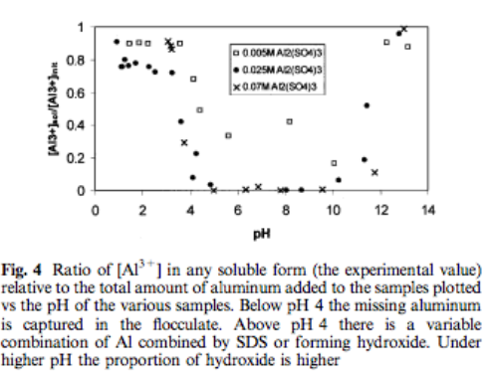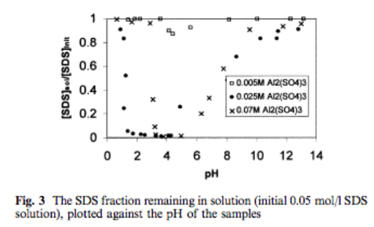

Figure 3

Figure 4

It becomes more difficult to interpret the data as the article continues. Figure 5 (shown below) appears at first glance to have multiple data points plotted without any apparent trend. The authors explain that the concentration of the amount of aluminum remaining in solution increases as Na+ ions increase. This information is not clearly conveyed in the graph. This figure cannot stand alone and requires one to extensively read the surrounding text in order to get an idea of what the graph is actually portraying.

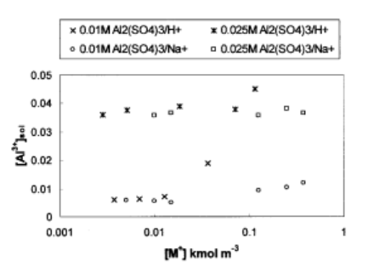

Figure 5

The last Figures (6 and 7) are slightly easier to understand. Figure 6 shows a decrease in SDS micellar aggregation with increasing pH. It is rather easy to see this trend. The legend is also clearly labeled. Figure 7 shows that substantial amounts of flocculate can be achieved in neutral, low acidic, and slightly basic conditions. The data point marks are easy to distinguish from each other for these graphs.

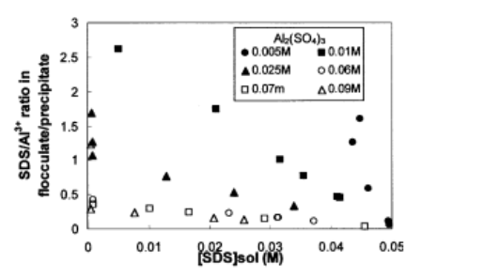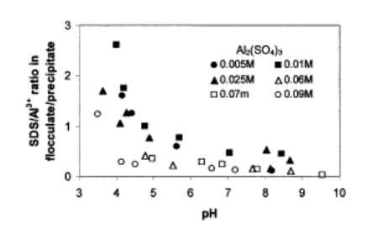

Figure 7

Figure 6

There is a small discussion of the findings under the “results” section. This is slightly problematic, as the results are meant to be left to the reader for open interpretation. The discussion, or lack, thereof is discussed in slightly greater detail in the next section.

**Discussion**

As stated in the above section, the placement of the discussion under the results heading is less than optimal. This is due to the fact that the results section should contain only experimental findings and should be void of opinions or analysis, allowing outside readers to formulate their own opinions on the findings.

Because there was no clearly stated hypothesis from the beginning of the article, it is difficult to determine whether the predictions and their relation to the measured results were adequately discussed in this section.

The authors of this article noted some issues they experienced, such as their realization that large amounts of Al(OH)3 along with the flocculate proved to be a bit troublesome in handlings. This gives individuals who are planning to replicate their findings a glimpse of what problems to expect should they follow the same procedures. In addition, the discussion provides future improvements to the methods by stating that working at more alkaline conditions would result in higher dissociation degrees and thus improve the efficacy of the process with compounds that have a higher pKa. Again, this provides useful direction for those who plan to attempt to replicate or modify this experiment.

**Conclusion**

The authors conclude the article by noting significant discoveries made as well as briefly restating the main concepts of micellar flocculation and SDS adsorption. This section makes general sweeping statements about the takeaways of the lab without providing a concise summary of the quantitative results obtained from the experiment. This weakens the conclusion, as the reader should be able to link such broad conclusion statements with specific data.

This section provides useful applications of the findings, such as the use of micellar flocculate in the concentration of metals and precipitation of their hydroxides, ultimately resulting in the release of surfactant. This type of information points readers in the direction of future exploration.

**Overall issues**

Over all, this article stresses the methods and results more so than the portions of the report that both precede and follow them. Though providing great detail in some areas, this gives the paper a certain imbalance, resulting in a less than optimal connection between the apparent hypothesis and the results that supported or refuted those predictions. The article as a whole is not very readable for individuals who are outside of this discipline, or who are even unfamiliar with surfactants and methods for analyzing them in general. The figures shown in the article do not efficiently summarize the findings in a manner cohesive enough for students as well as other individuals outside of the discipline to understand.